**PIZZA Sales SQL Queries**

**A.KPI’s**

**--Total Revenue**

select round(sum(total_price),2) as Total_revenue from pizza_sales_csv_file

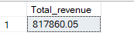

**--Average Order Value**

select Round(sum(total_price)/count(distinct order_id),2) as Avg_order_value from pizza_sales_csv_file



**--Total Pizzas sold**

select sum(quantity) as Pizzas_sold from pizza_sales_csv_file

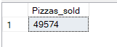

**--Total Orders**

Select count(distinct order_id) as total_orders from pizza_sales_csv_file



**--Avg pizzas per order**

select Cast(cast(sum(quantity) as decimal(10,2))/cast(count(distinct order_id) as decimal(10,2)) as decimal(10,2)) as Avg_pizza_per_order

from pizza_sales_csv_file



**B. Chart Requirements:**

**Daily Trend for Total Orders:**  
Create a bar chart that displays the daily trend of total orders over a specific time period. This chart will help us identify any patterns or fluctuations in order volumes on a daily basis.

**--Weekday-wise**

Select DATENAME(DW,order_date) as Order_days, count(distinct order_id) as Total_orders

from pizza_sales_csv_file

group by DATENAME(DW,order_date)

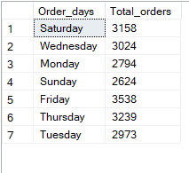

**--Month-wise**

Select DATENAME(month,order_date) as Order_days, count(distinct order_id) as Total_orders

from pizza_sales_csv_file

group by DATENAME(month,order_date)

Order by Total_orders desc

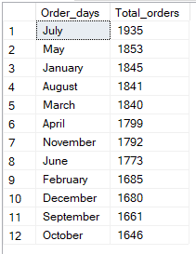

**2. Hourly Trend for Total Orders:**  
Create a line chart that illustrates the hourly trend of total orders throughout the day. This chart will allow us to identify peak hours or periods of high order activity.

Select Datepart(hour,order_time) as Hourly, count(distinct order_id) as Total_orders

from pizza_sales_csv_file

group by Datepart(hour,order_time)

order by Total_orders desc

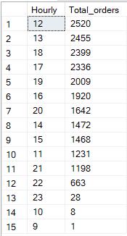

**3. Percentage of Sales by Pizza Category:**  
Create a pie chart that shows the distribution of sales across different pizza categories. This chart will provide insights into the popularity of various pizza categories and their contribution to overall sales.

select pizza_category,round(sum(total_price)*100/(select sum(total_price) from pizza_sales_csv_file),2) as Pct_of_sales

from pizza_sales_csv_file

group by pizza_category

order by Pct_of_sales desc

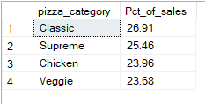

**4. Percentage of Sales by Pizza Size:**

**Generate a pie chart that represents the percentage of sales attributed to different pizza sizes. This chart will help us understand customer preferences for pizza sizes and their impact on sales.**

select pizza_size,round(sum(total_price)*100/(select sum(total_price) from pizza_sales_csv_file),2) as Pct_of_sales

from pizza_sales_csv_file

group by pizza_size

order by Pct_of_sales desc

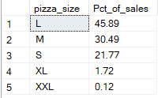

**NOTE: Always check that the subquery is filtering on the same logic as the outer query** if they need to be in sync.

**In the below example of *% sales by quarter* we are putting where clause in both the sub and outer query so the result should sync.**

select pizza_size,round(sum(total_price)*100/(select sum(total_price) from pizza_sales_csv_file where datepart(QUARTER,order_date)=1),2) as Pct_of_sales

from pizza_sales_csv_file

where datepart(QUARTER,order_date)=1

group by pizza_size

order by Pct_of_sales desc

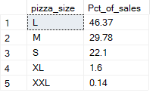

**5. Total Pizzas Sold by Pizza Category:**

**Create a funnel chart that presents the total number of pizzas sold for each pizza category. This chart will allow us to compare the sales performance of different pizza categories.**

Select pizza_category,sum(quantity) as Total_sales_by_category

from pizza_sales_csv_file

group by pizza_category

order by Total_sales_by_category desc

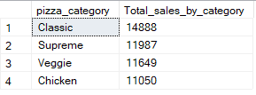

**6. Top 5 Best Sellers by Total Pizzas Sold:**

**Create a bar chart highlighting the top 5 best-selling pizzas based on the total number of pizzas sold. This chart will help us identify the most popular pizza options.**

--Top 5 by total Revenue

Select top 5 pizza_name,sum(total_price) as Total_revenue

from pizza_sales_csv_file

group by pizza_name

order by Total_revenue desc

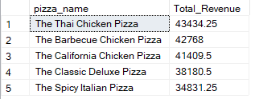

--Top 5 by Total quantity of pizzas sold

Select top 5 pizza_name,sum(quantity) as Total_sales

from pizza_sales_csv_file

group by pizza_name

order by Total_sales desc

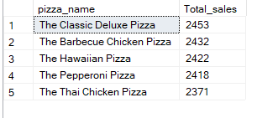

--Top 5 by Total_orders

Select top 5 pizza_name,count(distinct order_id) as Total_orders

from pizza_sales_csv_file

group by pizza_name

order by Total_orders desc

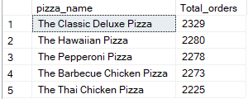

**7. Bottom 5 Worst Sellers by Total Pizzas Sold:**

**Create a bar chart showcasing the bottom 5 worst-selling pizzas based on the total number of pizzas sold. This chart will enable us to identify underperforming or less popular pizza options.**

--Bottom 5 by Total_Revenue

Select top 5 pizza_name,sum(total_price) as Total_revenue

from pizza_sales_csv_file

group by pizza_name

order by Total_revenue

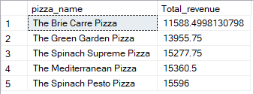

--Bottom 5 by Total quantity of pizzas sold

Select top 5 pizza_name,sum(quantity) as Total_sales

from pizza_sales_csv_file

group by pizza_name

order by Total_sales

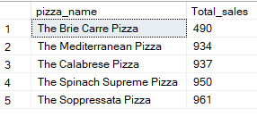

--Bottom 5 by Total_orders

Select top 5 pizza_name,count(distinct order_id) as Total_orders

from pizza_sales_csv_file

group by pizza_name

order by Total_orders

